

**Computational Intelligence & Deep Learning**

**Project**

**A.A. 2022/2023**

**Report**

* Giuseppe Aniello – badge: 643032 – email: [g.aniello@studenti.unipi.it](mailto:g.aniello@studenti.unipi.it)
* Edoardo Malaspina – badge: 578355 – email: [e.malaspina@studenti.unipi.it](mailto:e.malaspina@studenti.unipi.it)

Link of Google Collab:

<https://colab.research.google.com/drive/17XrwCK_g78ItCB2btP0UzIPw7Px4sVIz?authuser=8#scrollTo=6cLdjBo--khA>

SUMMARY

**1.INTRODUCTION** 3

**2. DATASET** 4

**3. CNN FROM SCRATCH** 6

**3.1 Build architecture of neural network model** 6

**3.2 Results** 9

**3.3 Consideration** 11

**3.4 Explicability of the model** 11

# **1.INTRODUCTION**

The aim’s project is to distinguish several kind of landscape: buildings, mountain, glacier, forest, sea and street.

In particular two classifiers will be developed:

* A classifier is developed using a CNN from scratch, performances and statistics are analyzed
* A classifier is developed using a pre-trained *keras* model using two different techniques. The former using *“Feature Extraction”*  and the latter using *“Fine Tuning”*. Performances and statistics are analyzed.

A comparison between the two classifiers is shown with the corresponding results.

Finally there is an explicability phase, for each classifiers are shown how result are obtained and intermediate phases of training phase, using different techniques:

* Visualization of intermediate ConvNet outputs (Intermediate Activations).
* Visualization of ConvNet filters.
* Visualization of Heatmaps of class activation in an image.

This phase is performed on an image that is not used in the training of the Neural Network model.

**2. DATASET**

The images show Natural Scenes around the world, in particular six different landscape are shown : buildings, forest, glacier, mountain, sea and street.

These images are available on Kaggle:

<https://www.kaggle.com/datasets/puneet6060/intel-image-classification>

**Content:**

* 25k images of size 150x150 distributed under six categories.
* Six classes.
* 351 MB.

These images are split up in different field: seg_data, seg_test and pred_data (this one is not used).

* Seg_data provides images for training data and it is used also for the creation of the validation set using validation split set equals to 0.2. At the and of the creation train data is made up of 11236 images, instead the validation set is made up of 2808 images. To store images are used tensors through the function of keras :

*Image_dataset_from_directory()*

This function is typically used for loading and preprocessing image data from a directory structure and creating a dataset that can be used for training deep learning models.

* Seg_test provides images for test data, it contains 3000 images. Also here are used tensor to store it using the same function above.

All the images have the same size 150x150, before train the model an operation of normalization Rescale is performed on each dataset (train, validation and test) because it helps improve the performances and convergence of the model during training.

A random image of each class is printed to check the correct upload of the images:

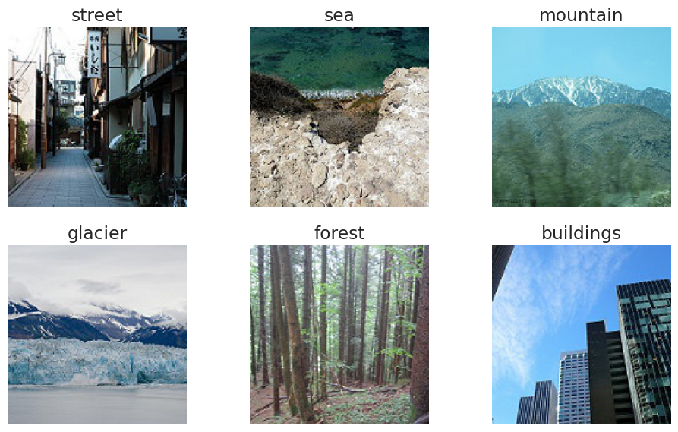

**Fig.1** Random image of each class with the correct label

A check on the distribution of the training’s classes is performed and the results show that the train set is balanced.

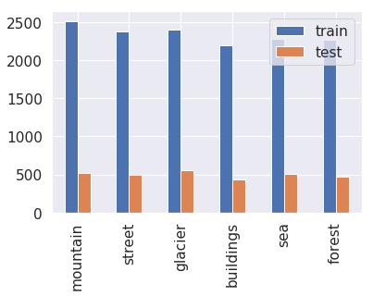

**Fig.2** Distribution of training and test

**3. CNN FROM SCRATCH**

The first classifier is built using a CNN *(Convolutional Neural Network)* from scratch, this means implanting all the necessary components of a CNN algorithm without relying on pre-existing deep learning frameworks or libraries. The language used to implement it is Python using Google Collab.

## **3.1 Build architecture of neural network model**

The CNN model is built using the Keras API with TensorFlow as backend. An extract of the code is shown to visualize the model components’:

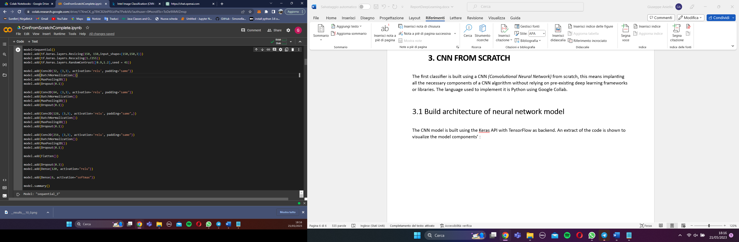

**Fig.3** Overview of the model’s code

A sequential model object is used to allow to stack layers on top each other sequentially.

Two layers of normalization: Resize and Rescale are performed. The former provides a resize of the input images which is (height = 150, width = 150). The latter scales the pixel values of the input images between 0 and 1 . In this case divides the pixel values by 255 to achieve this scaling. These layer ensure numerical stability during the training process and accelerate the convergence of the training process.

One layer of augmentation is added *“RandomContrast”* , that randomly set the contrast of the image with a value that belongs to the range [0.8 , 1.2].

Four Convolutional layers are used to extract spatial features from input data. Convolutional layers play a crucial role in CNNs and are specially designed to capture local pattern and spatial relationships within the data. A Convolutional layer is made up of:

* Filters: in each layer their quantity is increased from 32 to 256, act as feature extractors, are small matrices or tensors that contain learnable weights, each filter has a limited receptive field, meaning it captures information only from a small local region of the input and allow to focus on specific features within his receptive field.
* Kernel: in each layer there is a kernel 3x3, it is used for the convolutional operation the kernel is slide over the input data in a systematic manner and generates a feature map.
* Activation Function: in each layer is used as activation function *“ReLU”* (Rectified Linear Unit). The ReLU activation function introduces non-linearity to the network and helps in modeling complex relationships between inputs and outputs.
* Padding: in each layer is set to “same”. The padding refers to the technique of adding extra border pixels to the input image or feature map before performing the convolution operation. It helps in preserving spatial dimensions and addressing the issue of information loss at the edges of the input during convolution. Setting the option to “same” means that the number of padding pixels added is determined by the size ok the convolutional kernel. The padding is evenly distributed around the input image or feature map to ensure that the resulting output feature map has the same height and width as the input.

At end of each Convolutional layers is added a *“BatchNormalization”* layer and a *“MaxPooling2D”* layer. The former normalizes the activations of the previous layer, making the model more robust to changes in the input distribution. The latter performs max pooling, which down samples the input feature maps by selecting the maximum value within each pooling region. It helps reduce the spatial dimensions of the feature maps.

On the top of the Convolutional layers’ block is added a Flatten layer, it flattens the multi-dimensional output from the previous layer into a 1D vector. This prepares the data for the fully connected layers.

Finally two Dense layers are used. The first one is made up of 120 neurons (Different trials were done and the best was with this numbers of neurons) and as activation function is used *“ReLU”* . This layer connects every neuron from the previous layer to the neurons in the current layer. The Dense layer’s aim is to learn complex pattern and relationships in the input data and is responsible for making predictions or producing output based on the learned representations from the preceding layers.

Instead the last Dense layer is made up of 6 neurons corresponding to the six classes in the classification problem. As activation function is used *“softmax”* because allows to obtain probability scores for each class, allowing the model to provide class predictions.

At end of each block is also added a *“Dropout”* layer, it randomly sets a fraction of the input units to 0 during the training, which helps to prevent overfitting.

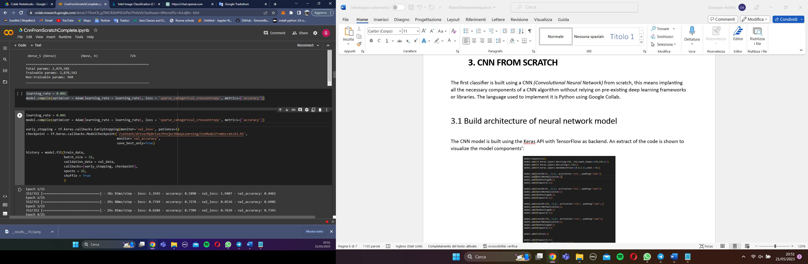

**Fig.4** Code of the compile and fit model

After defined the model’s layers a CNN model is compiled and trained using the TensorFlow library.

* Compilation:
* The optimizer is set using the Adam optimizer with a learning rate of 0.001. The Adam optimizer is a popular optimization algorithm commonly used for training neural networks. It combines the advantages of two other popular optimization algorithms, namely Adaptive Gradient Algorithm (AdaGrad) and Root Mean Square Propagation (RMSProp). Adam adapts the learning rate for each parameter based on the estimates of both the first and second moments of the gradients.
* The loss function is set to *'sparse_categorical_crossentropy'*, which is suitable for multi-class classification tasks.
* The metric used to evaluate the model's performance is 'accuracy', which measures the percentage of correctly classified samples.
* Training:
* Before the training are defined the Callbacks : the “*EarlyStopping callback”* is used to monitor the validation loss during training. If the validation loss does not improve for 5 consecutive epochs, training will be stopped early to prevent overfitting and the *“ModelCheckpoint callback”* is used to save the best model weights based on the validation accuracy. The best model weights will be saved to the specified file path.
* The function *model.fit()* is called to train the model and requires the train and validation data, the *batch_size* is required and set to 32, which means the model will be trained on batches of 32 samples at a time and the number of epochs indicating the number of complete passes through the training data.

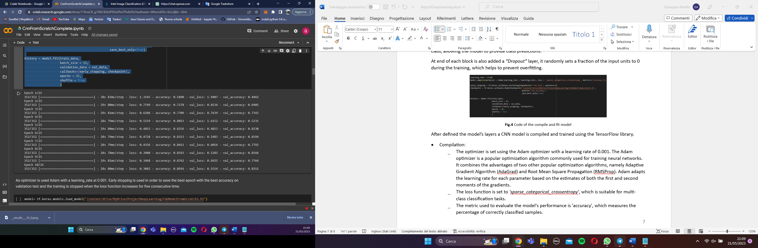

**Fig.5** Show values of loss and accuracy for each epoch.

**3.2 Results**

After the training different results are shown:

* Accuracy and Loss on test set is performed and the following results are obtained:

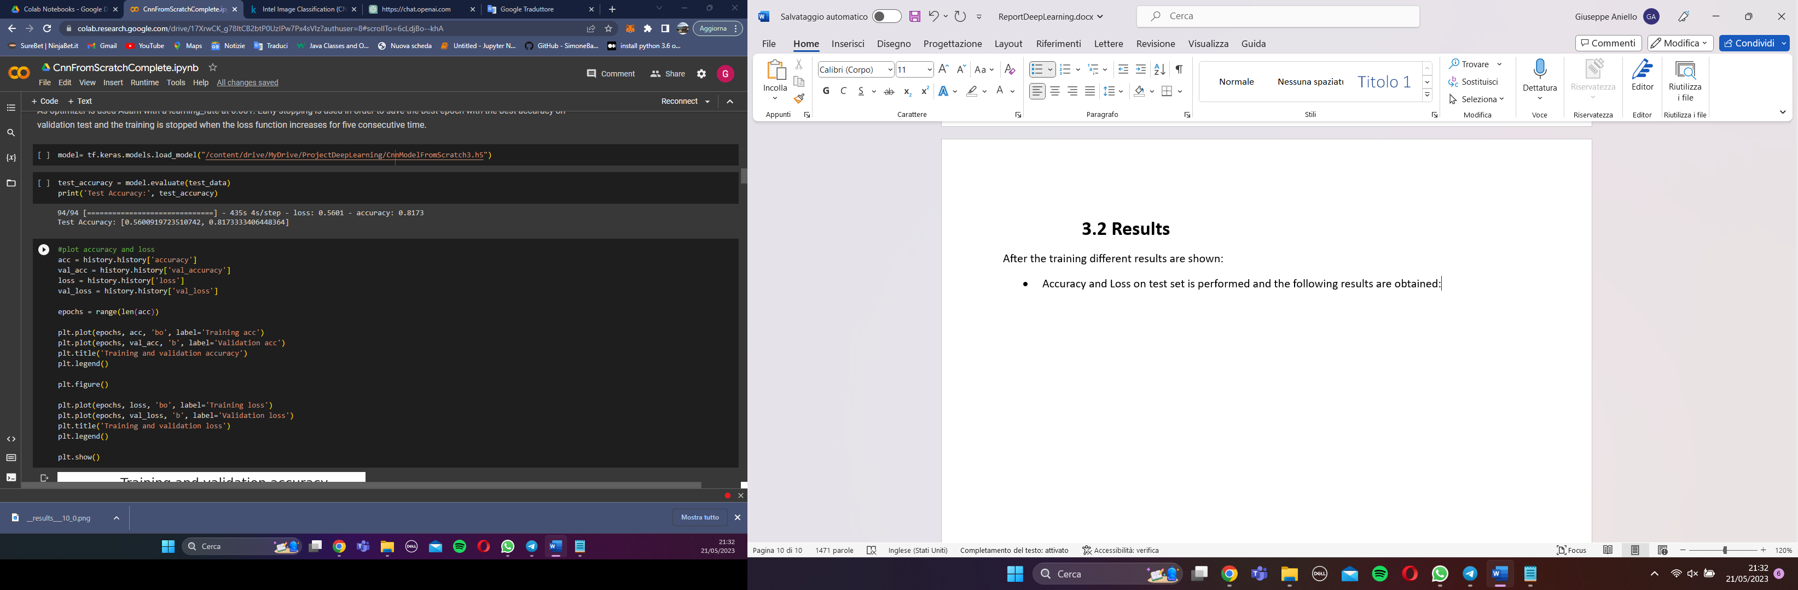

* Plot of training and validation accuracy:
* 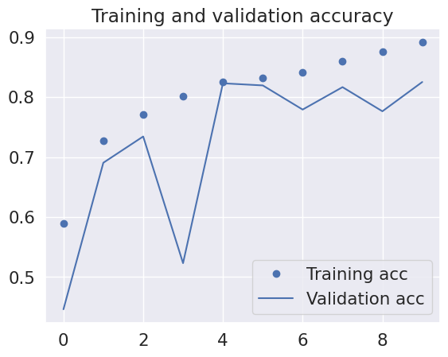
* Plot of training and validation loss:

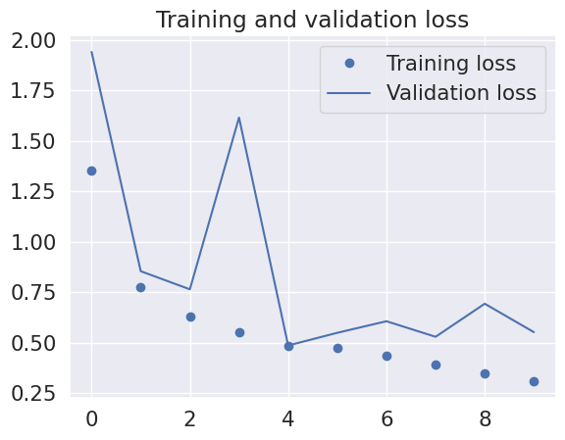

* Confusion Matrix:

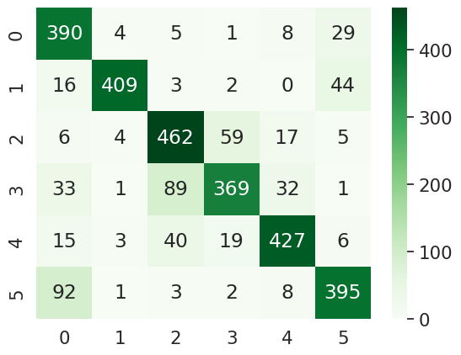

* Report with Precision, Recall, F1-Score and Support:

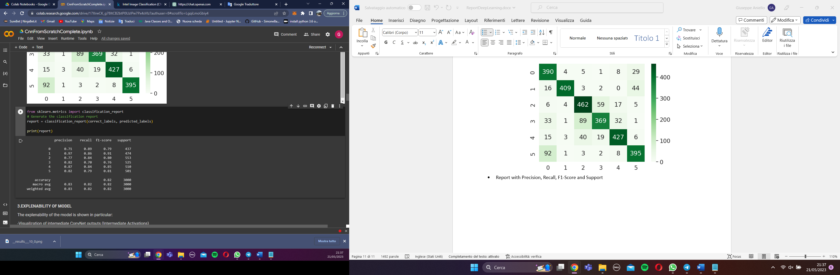

Where :

1. -> buildings
2. -> forest
3. -> glacier
4. -> mountain
5. -> sea
6. -> street

* Roc curves:

**3.3 Consideration**

**3.4 Explicability of the model**

In this phase is analyzed what happen inside the Convolutional layer, an image that does not belong to the training of the model is taking in account:

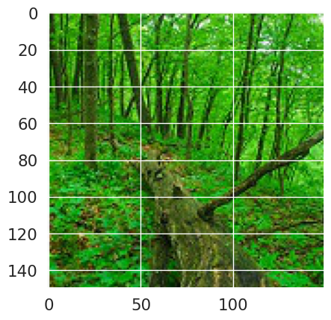

**Fig.6** An image of a forest from test set.

In particular three techniques will be used to show what happens inside the ConvNet :

* Visualizing intermediate convnet outputs: this operation is useful to understand how successive convnet layers transform their input, and to get a first idea of the meaning of individual convnet filters.

To do this operation is upload the model of the CNN from scratch previously trained, convolutional and max_pooling layers are printed and a feature map 150x150 with 32 channels is shown:

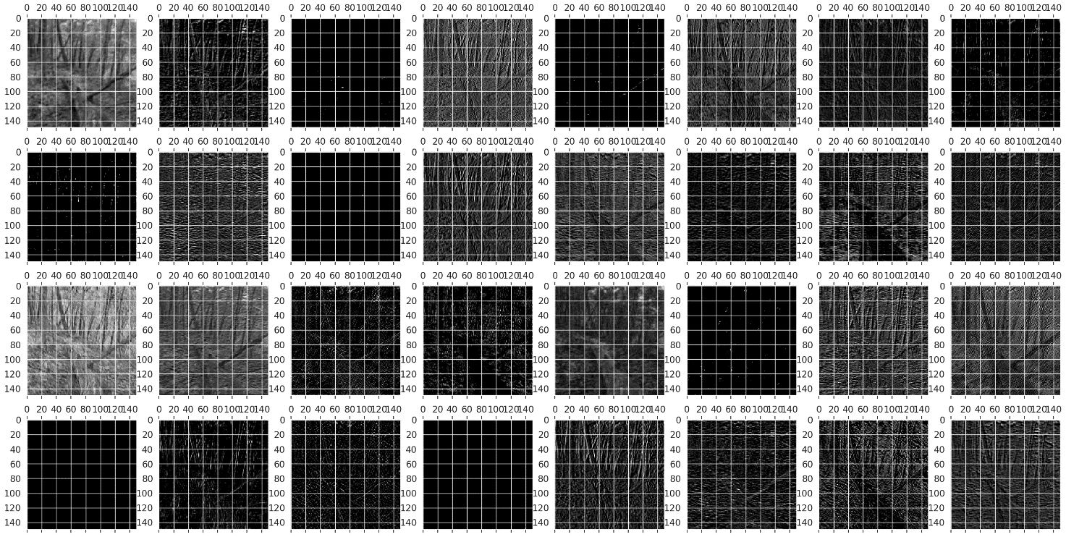**Fig.6** Feature Map 150x150 with 32 channels

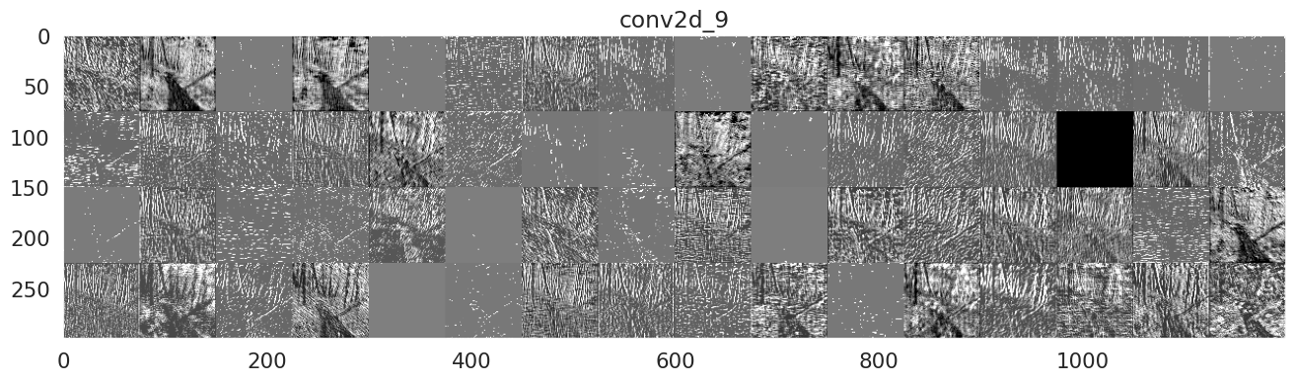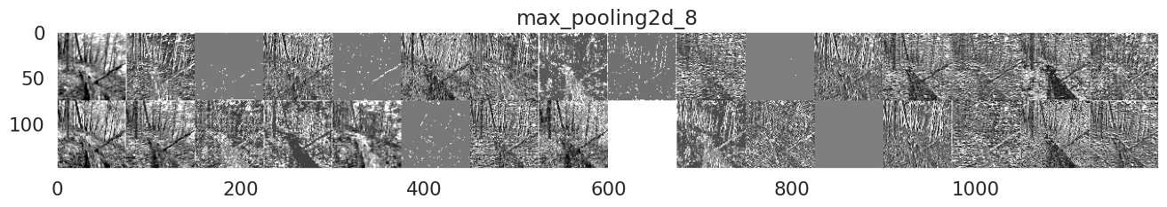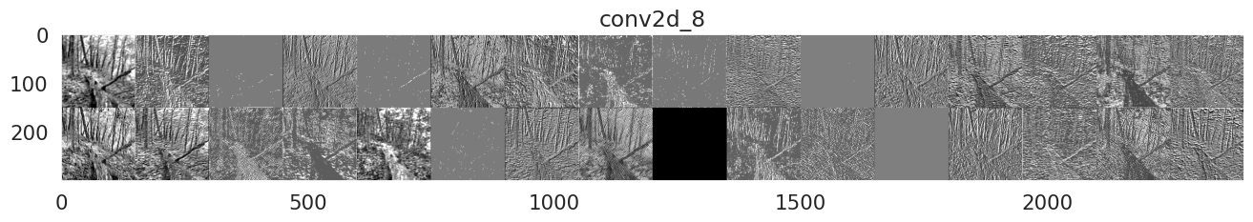

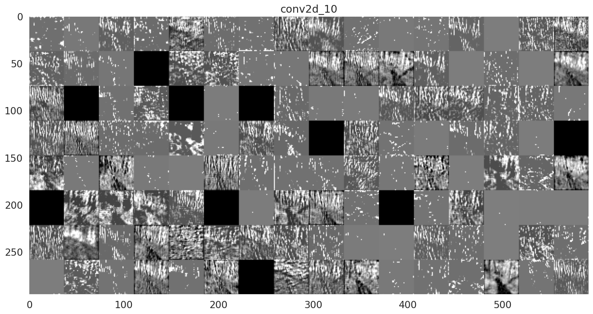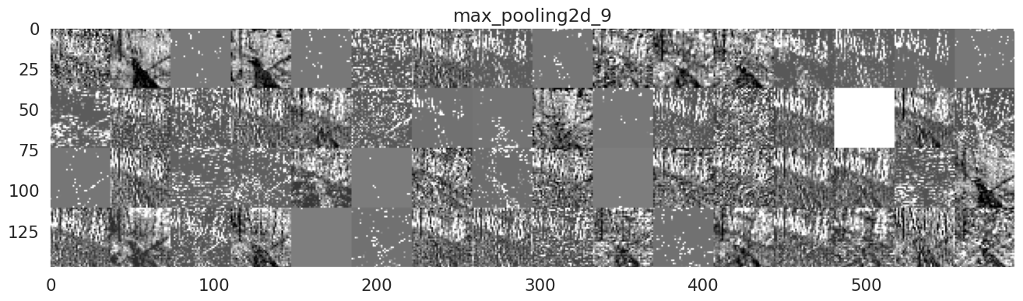

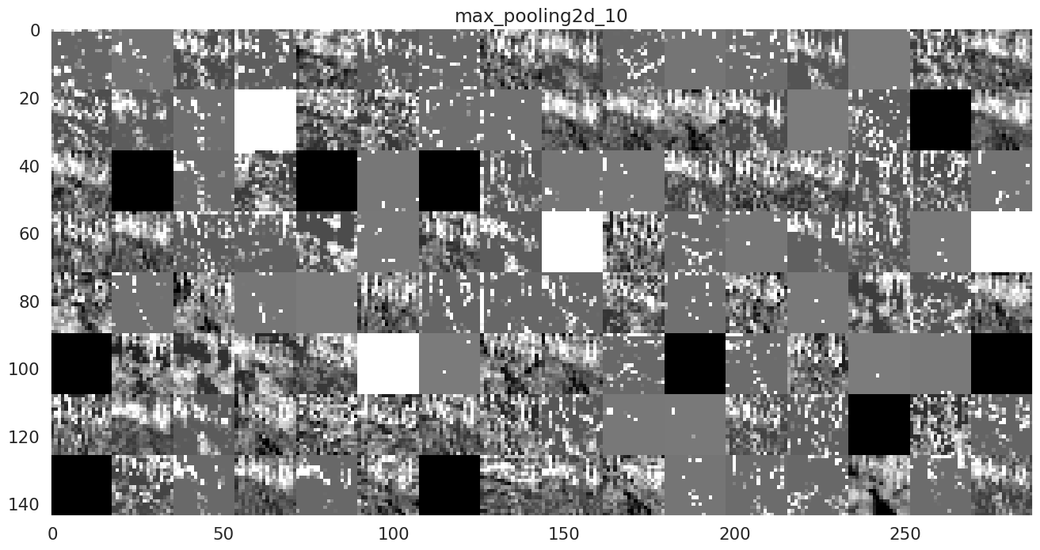

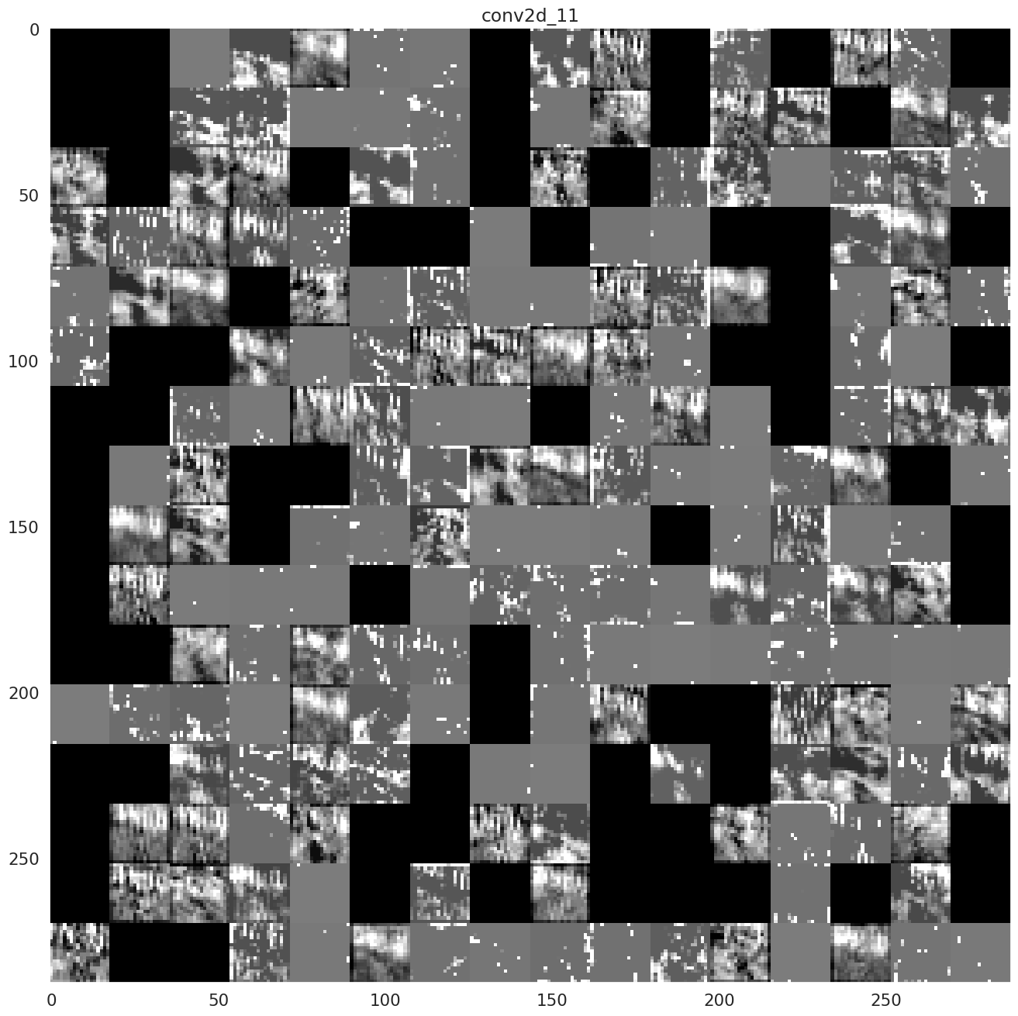

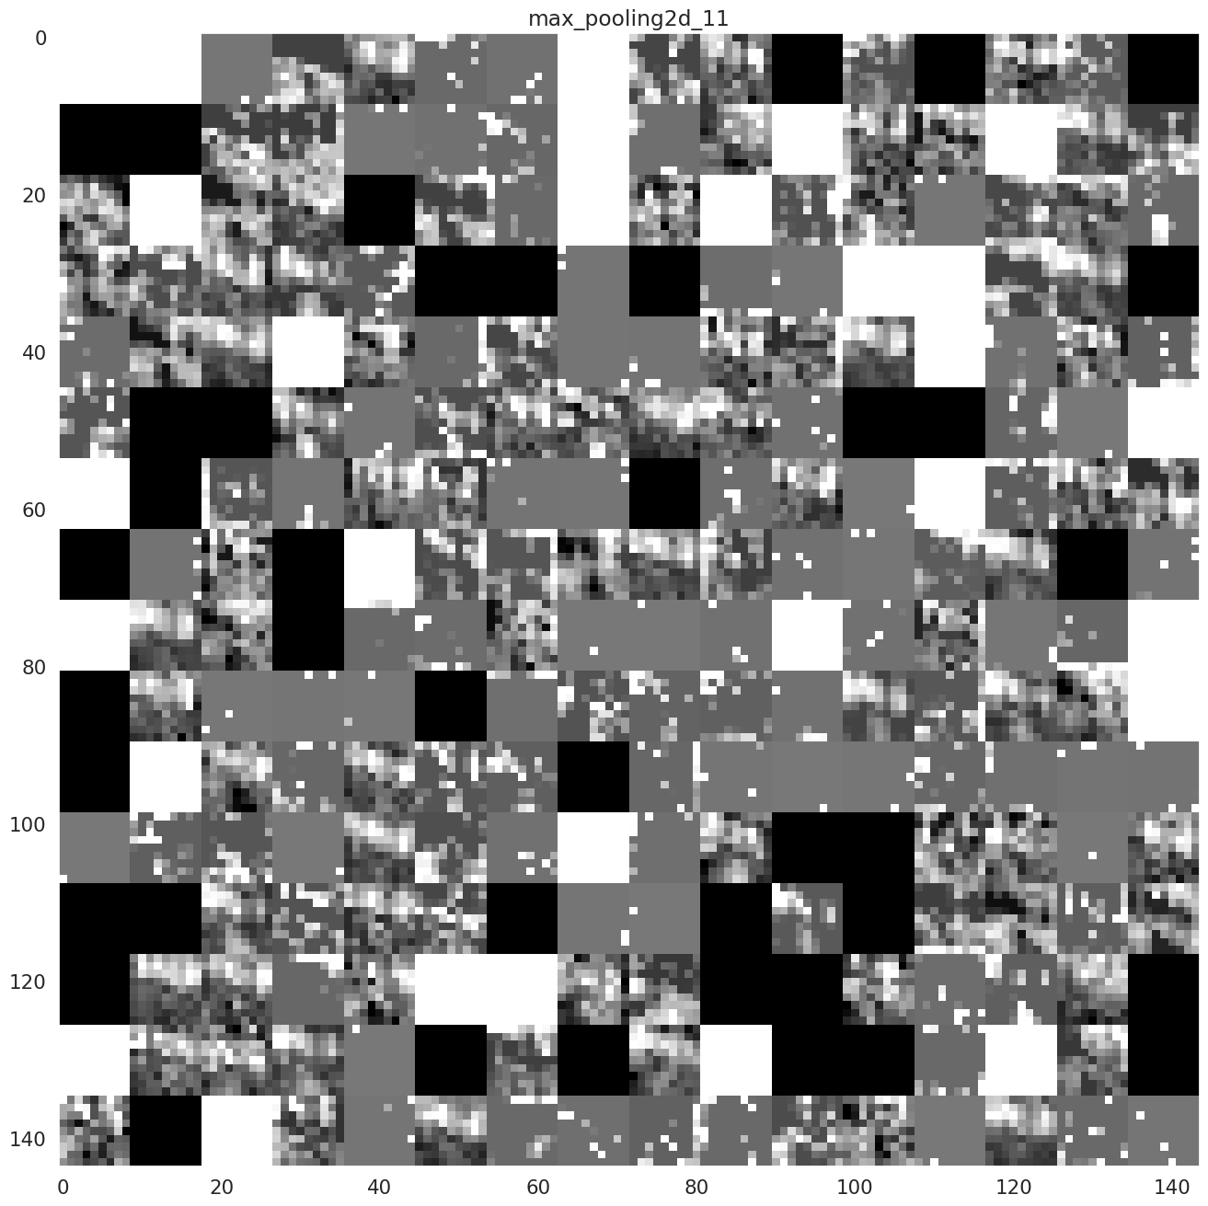

This passage shows what happens inside the convolutional and max_pooling layer.

* Visualizing convnet filters: this is useful to understand precisely what visual pattern or concept each filter in a convnet is receptive to:

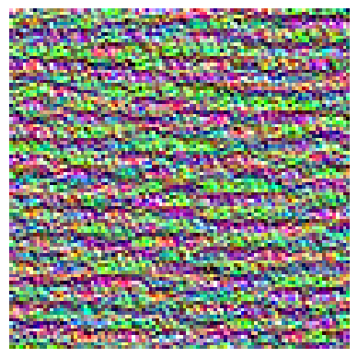

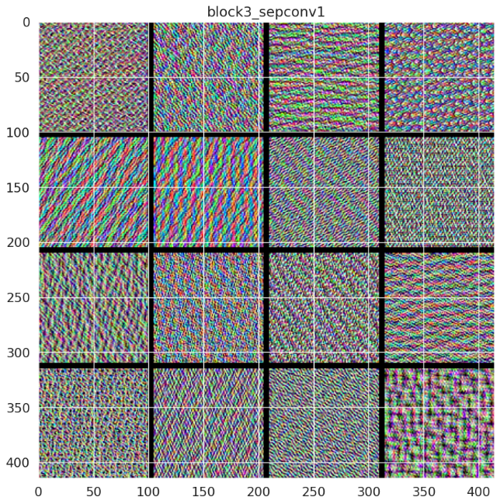

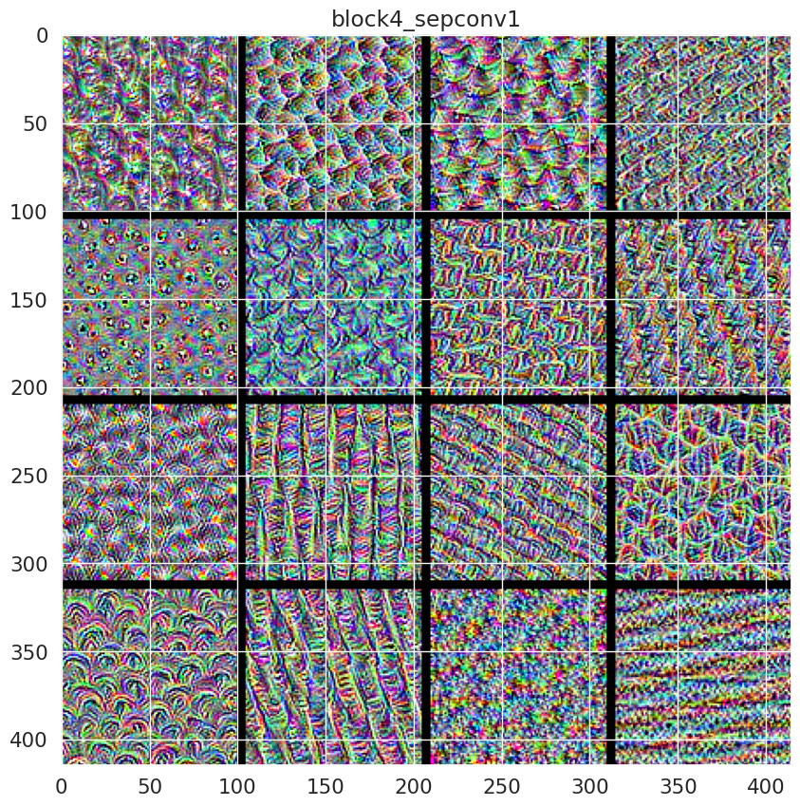

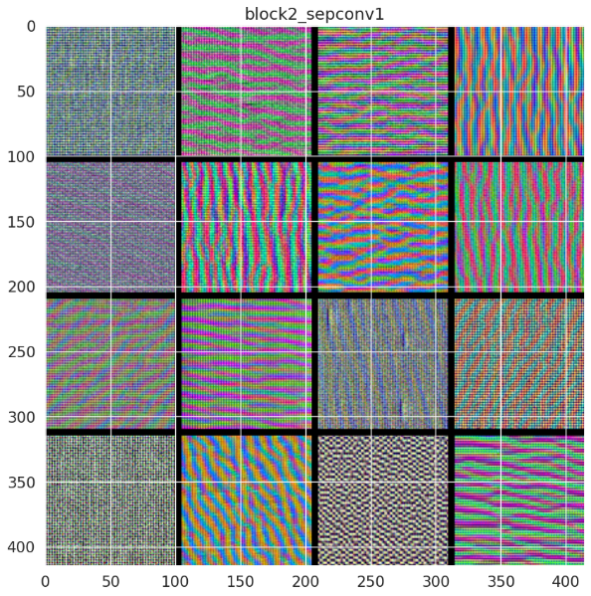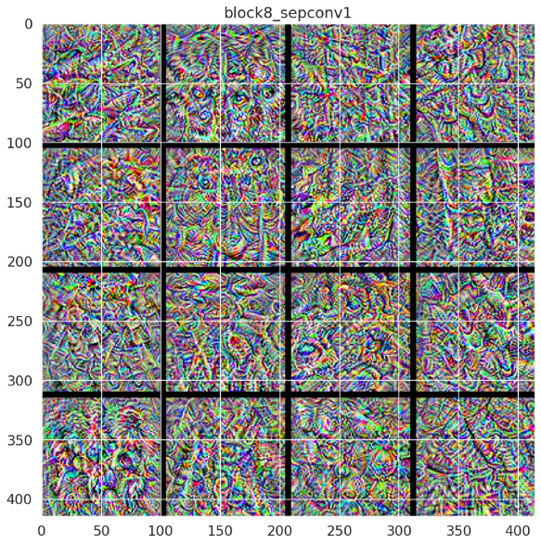

* Visualizing heatmaps of class activation in an image: this is useful to understand which part of an image where identified as belonging to a given class.

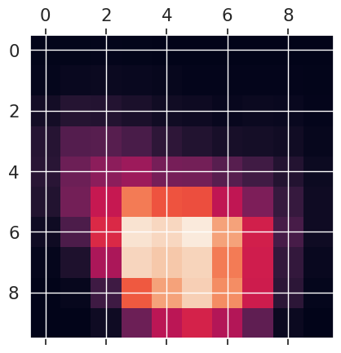

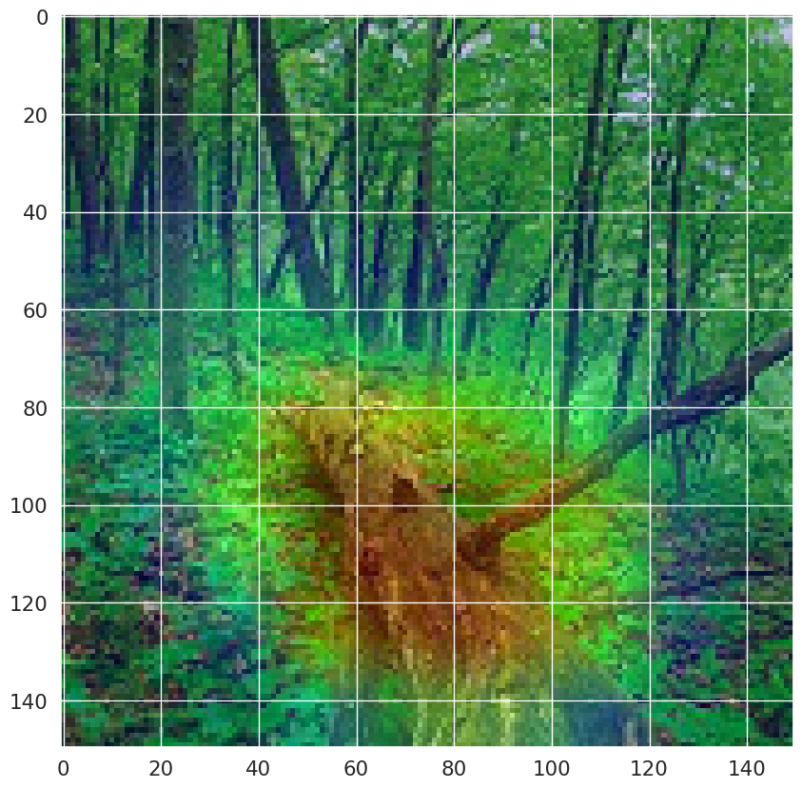

# **4. PRE-TRAINED MODEL WITH CNN**